Reagan Esteves, Jamie Hartman, Charles Tyndal, and Chenyu Zhao

CMPS-4010-01

Dr. Zheng

December 10, 2022

**Milestone 4: Skin Disease Diagnosis on Darker Skin Tones**

1. **Software Development**

Since milestone 3, new attempts have been made to implement contours and superpixels. The contours and superpixels code was created based on using the prototype code as a base. Superpixels are when pixels of an image are grouped together by taking the average color of the middle pixel in a cluster of pixels. The result of the grouping of pixels can be viewed as an image over-segmentation. We chose to implement superpixel segmentation because compared to doing segmentation on images, superpixel segmentation can reduce the number of image primitives. The reduction of image primitives will help improve the overall efficiency of detecting the skin area with the disease. The contours and superpixel segmentation also make it easier for bounding boxes and masks to be on the area with skin disease.

In the block of code for contours, it first makes the image gray, as cv2 threshold requires to do so, then it smooths the image with a gaussian blur. Afterward, when it detects a contour it places a bounding box over the contour. There seem to be more contours in the area of diseased skin so hopefully, some bigger bounding box can be placed around the area with the greatest number of contours in future code. Another attempt uses SLIC from skimage.segementation to segment the superpixels. The SLIC import and line of code segments change in colors and clusters similar colors. The prototype code and the code for superpixels/contours are included in our drive link on page 7.

1. **Results from Software Development & Task Work**

In milestone 3, the Buruli Ulcer (BU) and Yaws images were run through the prototype segmentation code and the results of the bounding boxes were recorded on an excel sheet. Similarly, the Leprosy was run through the prototype code and the quality of the boxes was graded the same using the three categories: bad, mid, and good. The results were bad if the bounding box did not get the body part (region of interest), mid if the bounding box had the body part and the background, and good if the bounding box was around the body part. Figure 1 shows a sample set of how the image results were categorized where the images labeled bad had a boundary box on a feather in the upper left corner rather than on the foot. The mid result included the foot in the boundary box, but also included the background such as the bowl. The mid result could have been changed to a good if the boundary box was only on the foot. The good result had the boundary box focused only on the arm.

After milestone 3, we realized each member grading the quality images may lead to possible discrepancies on what we consider good, mid, and bad. To reduce the disconnect between different people grading different images, we all went over each other’s grades and came to a consensus on every result before putting the results into graphs. The BU (650 images) pie chart had 34.5% good, 33.2% mid, 32.0% bad, and 0.3% were no result (Fig 4). The Yaws (90 images) was 24.1% good, 64.4% mid, and 21% bad (Fig. 5). Three images were not counted for the rating as we were unable to determine what the region of interest was. For Leprosy we had 134 images that we ran finding that 41.9% were good, 22.6% mid, and 35.5% bad (Fig. 6). Based on the pie chart results, a correlation was detected for the bad results where most images had a busy background such as random objects rather than a uniform background.

The results for the superpixels and contour are illustrated in figures 2 and 3. Based on figure 3, the superpixels were able to group the pixels with similar colors together making the outline of the body part (arm) more defined. The contour boxes are detected based on slight changes in color on the image.

1. **Meeting Plan & Accomplishments**

In November, we were able to access the data set and our meetings consisted of going over the data set and the prototype code. In December we ran more data sets with the prototype code and attempted superpixel. We are currently working on two sets of code building off of the prototype. One code detects contours, and changes in color, in images and places a bounding box around them. We are hoping to put a mask, similar to the prototype code, over the area with the most contours. Another code, made by Reagan, segments superpixels using SLIC. Similar to the previous code, we aim to place a mask over the segmented section with the diseased skin. We want to first blend the colors of the superpixels segments to allow Pytorch to detect the disease with greater accuracy. Both of the codes are still in the works as we have yet to combine the superpixel code with the prototype to successfully generate the mask and the bounding box which will be done by Jamie and Charles. A filtering combination with superpixels will be implemented by Reagan and Chenyu. Moreover, we hope to compare the superpixel results with the prototype code to see if there are any improvements that will be evaluated by the whole group for consistent ratings.

1. **Timeline**

Since milestone 3 we have worked on a prototype code for segmentation to obtain the region of interest and a prototype code for superpixel and contour. We are currently on par with our timeline and will revise our prototype code and try to combine the superpixels with the prototype code in early January. We also plan on trying different filtering combinations with the superpixel to observe if there was an increase in good results.

1. **Figures**

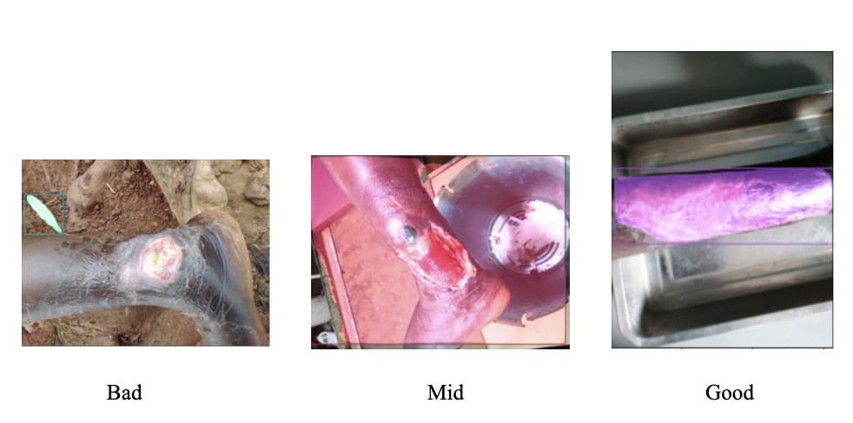

**Fig 1. Sample of Result Ratings**

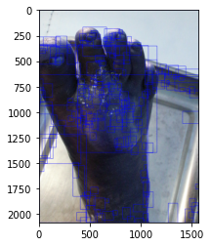

**Fig 2. Contour Code Result**

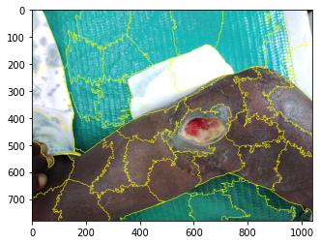

**Fig 3. Superpixel Code Result**

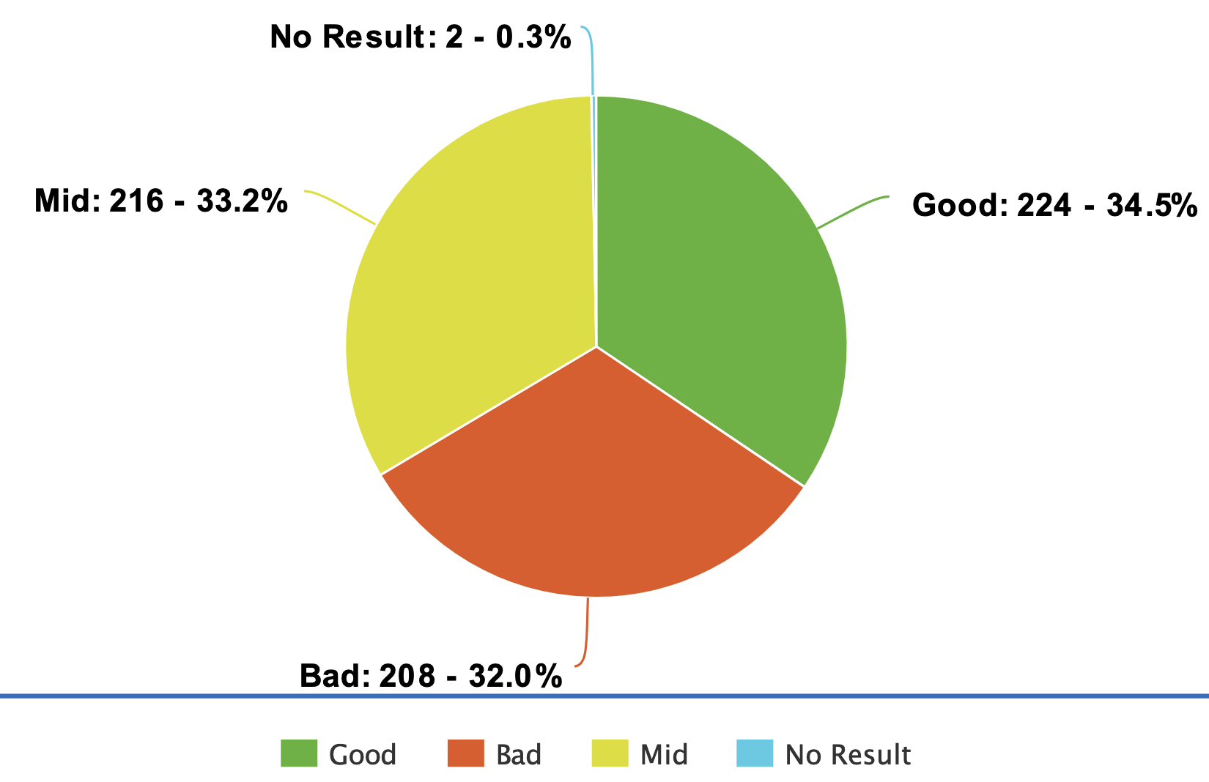

**Fig 4. Segmentation Result for Buruli Ulcer**

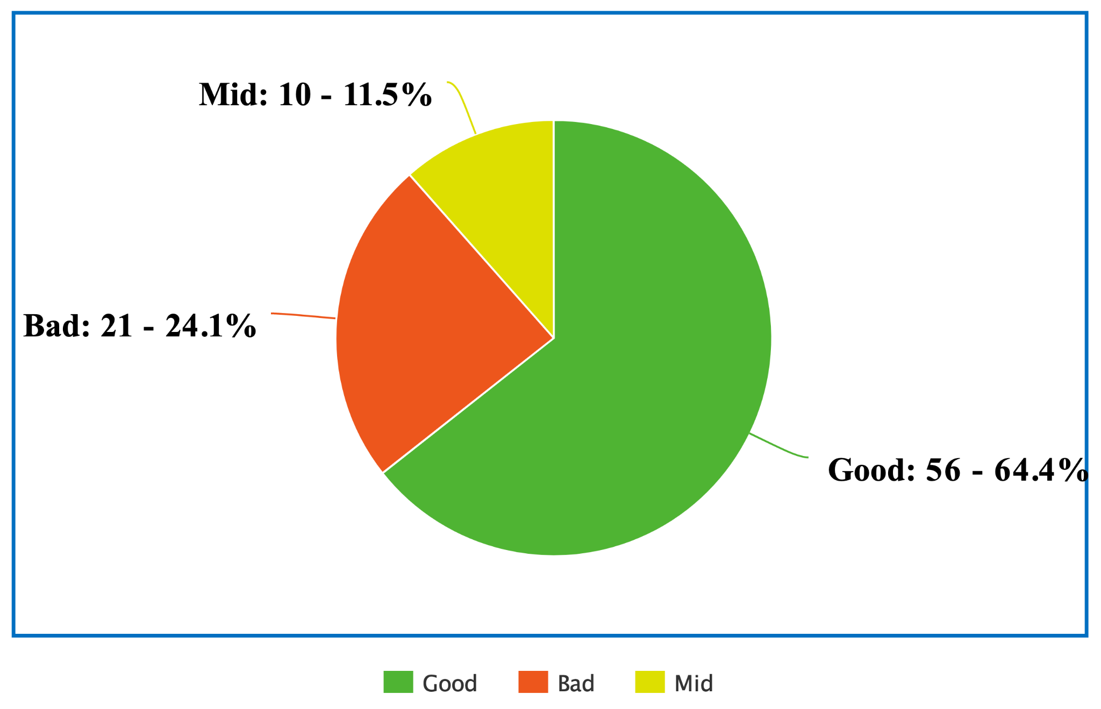

**Fig 5. Bounding Box Result for Yaws**

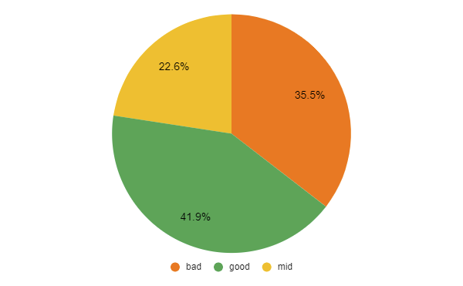

**Fig 6. Bounding Box Result for Leprosy**

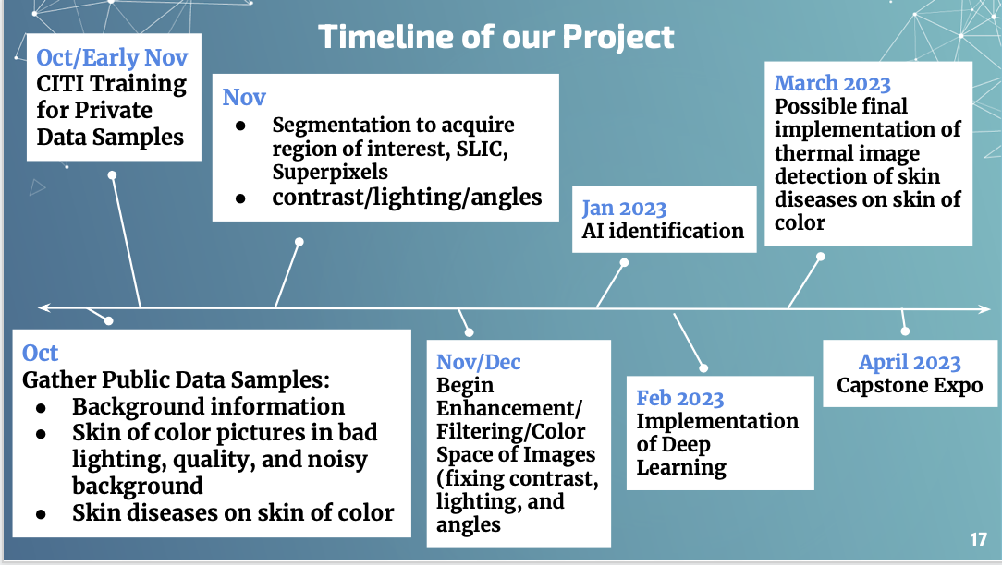

**Fig 7. Timeline of Capstone**

### [Capstone Drive](https://drive.google.com/drive/folders/1rpBsAFPqcA59arrNLMuPNAczhmAWk4xK?usp=share_link)